After The Masters

Art & Yoga Studio

Newsletter
News & Events  Article  Pose of the Month  Links & Resources  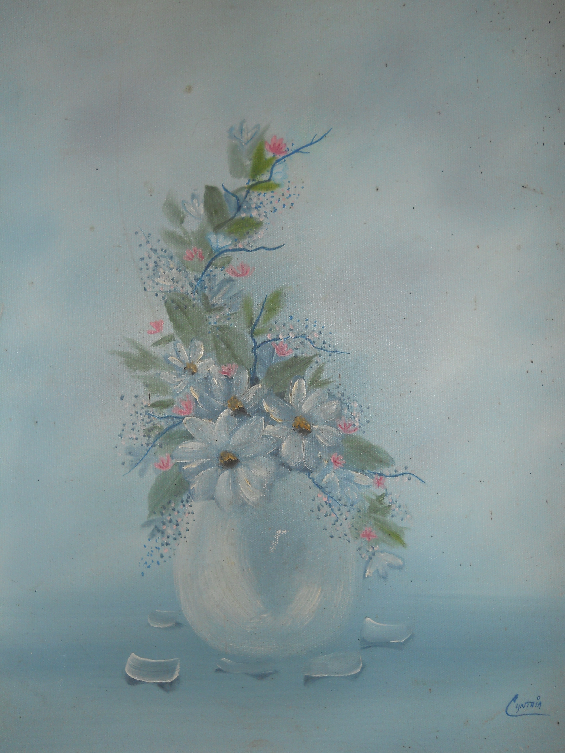  Oil painting  Cynthia Limeberry | April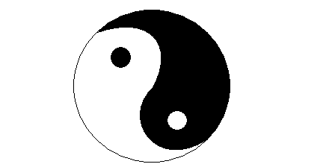  News & Events  The schedule for April is now online. Thanks for your continued support.  The latest winner of our monthly $50 drawing is…  Jennifer  Article- Yoga, the Perfect “Union”  Take a moment and step outside and inhale deeply –big Buddha breath expanding throughout the body. Notice the sensations as the cool air enters the nostrils, as the membranes moisten and warm the breath in preparation for entering the lungs and blood stream. Hold the breath in until you begin to feel as if you need to release and then swallow (this may not be easy to do at first, like everything else it takes patience and persistence). You should feel the panic sensation subside and be able to comfortably hold the breath a little longer. Slowly exhale.  There are many interpretations of pranayama depending on the type of yoga. Some feel pranayama should only be practiced after “mastery of asanas”, while others start immediately. It’s my thinking that this practice should be introduced from the beginning with caution and patience. I am not sure that anyone can master asanas completely and certainly not attain any level of mastery without incorporating some control of the breath. At first the two are separate practices, the mind and body have to focus on moving and somehow remember to breath.  Pranayama or control of the breath begins with focus and concentration on the breath. Breathing is a natural process that most of the time we forget about. It is not even noticed as it changes in response to outside stimuli- emotions, air quality and temperature, movement, illness, etc. We can never be free of these influences, however we can learn to notice and adjust the breath to keep not only the breath even and calm, but also to keep the mind and body calm.  The above practice is a perfect example of this.  Pranayama is a bridge between the outer, physical practice of asanas and the inner, mental practice of meditation. On this bridge is where the two practices merge and we enter a state of perfect surrender. Body and mind completely surrendering to the life force or the breath within. The mind and body give way and allow the breath to become the guiding influence that leads the separate practices of asana and meditation into the singular practice of Yoga (the term Yoga translates to “union”).  This “union” is also where the usual separation between you and the pose dissolves. You’ll hear the body more clearly through the breath than through the mind. The breath has no ego or uncertainty so the body moves when its ready and willing, not when pride pushes you or fear stops you.  Moving consciously with grace and openness- the perfect union.  Pose of the Month  Balasana or Child’s Pose- This pose gently stretches the hips, thighs and ankles of the lower body and the lower back, shoulders and neck of the upper body. This pose is a great stress and fatigue reliever. Therapeutic for neck and back pain as well as diarrhea. Avoid this pose during pregnancy or with any knee injuries (unless under proper supervision with the proper support from props).  Begin kneeling on the floor. Bring the knees to hips distance with big toes touching. Tuck the tailbone gently and sink the hips toward the heels. Slowly round over releasing the belly, ribs, shoulders and forehead toward the floor. This is a resting pose so release and soften especially through the hips, thighs and ankles. Rest the arms down by the side with palms up (which will allow more softening through the shoulders and side body) or with the arms extending forward (which allows more softening through the back of the neck). Breathing can become labored in this pose, focus the breath into the back body expanding through the lower back on the inhale instead of trying to force the breath into the belly or chest.  Supported variations include placing a blanket between the back of thighs and calves and/or a rolled blanket under the ankles, which make this pose more comfortable and restorative.  Other variations will be added to the pose directory on our website at afterthemasters.org  Links and Resources  AfterTheMasters.org

